We have been so fortunate with the weather while our Comenius visitors have been with us. They have spent their time exploring the local areas as well as spending time with children in school. Our Heads (Freddie Gaskin and Bethany Bradford) and Deputies (Jacob Hessian and Eleanor Offord) along with our lead of the Comenius work (Lucy Wilcock and Hayden Best) have done a wonderful job of welcoming them and showing them around our school. The welcome on the playground and in our assembly brought a tear to many eyes. The staff and governors have worked really hard to ensure that this visit has gone well and I am very grateful for their support. The links we have made with these schools are long lasting and will continue to enhance the learning in school. Our visitors were glowing about how delightful our children are and they were full of admiration of our school grounds and building. One teacher described our school as a ‘house’ as there is a strong sense of family and belonging. They really liked our Carleton Code and are taking this concept back to their own settings.
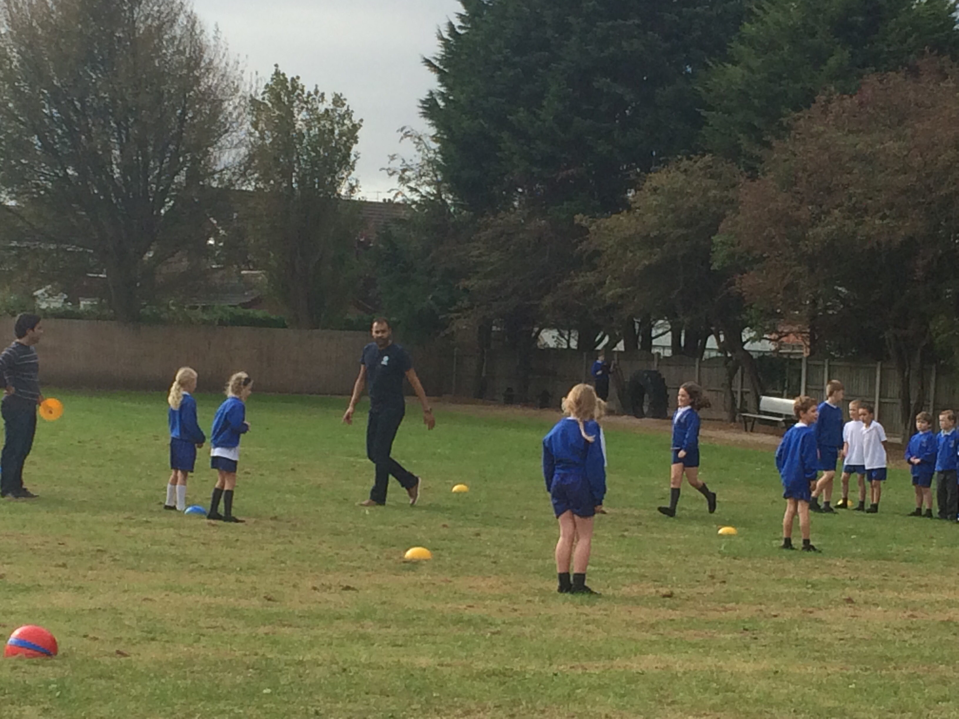 This is a photograph of the Spanish teachers working with Doves.
We would like to say thank you Mr Jackson for the super job of refurbishing our sign beside our school to commemorate the Lottery Funding we received. Our thoughts are also with the Hodgkinson family as their son Kai is recovering from major surgery in Leeds hospital. We wish him a speedy recovery.
Christmas is coming …We are already busy planning our Christmas festivities and are all very much looking forward to this magical time of year.
At the beginning of December our beautiful Christmas trees will arrive. These always come from the Plant Place and smell and look wonderful.
The children will be busy making decorations for the school, which will be on display for all to see.
Our Little Chicks, Ducklings and Key Stage 1 children will be busy rehearsing for their Christmas Play which will take place during the week commencing the 8th December. Full details and ticket requests will be sent out nearer the time.
There will be Christmas Parties for all the children (dates to be confirmed) and our usual PTFA Christmas Disco on Monday 15th December.
Christmas lunch has been scheduled for 17th December and all packed lunch children are welcome to join us for a festive school meal with crackers and carols.
We have also been very lucky to secure the beautiful Rossall Chapel for our Carol Service. This will take place on Tuesday 16th December at 6pm. We hope that you will all be able to join us for what promises to be an enchanting evening.
The decision over the changes we have made to the performances we lay on over the school year was made with all of the teachers. We spent time reflecting on how difficult it has been in the past to accommodate families to watch our Christmas performances; with the children having to perform many times. This naturally results in the enjoyment factor getting lost in the process. The concept of spreading our productions over the year would both help us as a school lay on better, more polished productions as well as support our families in managing to see their children. It also helps provide the opportunity for each phase to enjoy their moment on stage. Any changes that take place are always made with the very best of intentions and with the main aim for our pupils to thrive and provide opportunities for us to work more closely with families.
Notices: Petition for School Crossing Patrol is in our reception.
Odd job person wanted please whenever possible. Please see Mrs Farnworth if you are able to help us in any way.
Toddler group at St Hilda’s Church Hall are held on Mondays and Wednesdays at 10:00-11:30
Rossall School will be hosting their Open Morning on Saturday 4th October at 10am. The Head Ms Elaine Purves would like to invite parents and pupils of Carleton Green School to visit the outstanding 160 acre campus by the
sea. It’s the perfect opportunity to meet the pupils and staff, view the facilities of the Senior School and learn about the scholarships and bursaries which are available.
Dates for your Diary
Week beginning 6th December – Open afternoons for prospective parents 2015-16
7th October – Hawks’ (Miss Deane) Class Assembly
8th October – Open surgery from 9:00 for the completion of care plans with the school nurse and Mr Vaughan
- PTFA meeting in school from 17:30 . All parents are welcome.
- Football match against Hambleton after school.
- No netball
15th October – Parents’ Evening from 15:00. This year you will receive your child’s targets during this meeting. Shooting Stars books will be sent home at the close of each full term so that you can see a full coverage of your child’s learning.
- No netball
21st October – Falcons’ (Mrs Harding) Class Assembly
24th October – Open Afternoon. We would like to invite all existing parents to come into school from 1:30. We are going to be holding a variety of sporting events as part of our link with our European partners.
Star of the Week certificates have been awarded to:
Darcey Dickson in Yellow Ducklings | Adam Rogerson in Green Ducklings
Jack Mercer in Parrots | Oliver Rogerson in Herons
Evie Crompton in Robins | Abigail Mackie in Owls
Logan Ormand in Doves | Matthew Kirkham in Kestrels
Hannah Gray in Hawks | Poppy Taylor in Falcons
Lucy Wilcock in Eagles | Well done!!! 

