Dates remaining for this term:
2nd Parent Forum ~ Monday 4th December. 18:00-19:00.
Tuesday 5th December ~ Dan Worsley assembly for the juniors.
Thursday 7th December ~ Wear a Christmassy jumper and bring a bottle for the PTFA Tombola
Friday 8th December ~14:30-15:30. Open afternoon to share how we carry out Guided Reading sessions in school.
Little Chicks’ and Ducklings’ Nativities ~ Tuesday 12th December at 09:30, 14:00 and Wednesday 13th December at 09:30
Years One and Two Christmas Productions ~ Thursday 14th December at 14:00, 18:00 and Friday 15th December at 09:30.
Christmas Lunch will take place on the 19th December.
Christmas Candlelit Carol Service ~ 19th December from 18:00 at Rossall Chapel. Please bring your children at 17:30 even if you are unable to stay. Every child has a part to play.
Thursday 21st December Non-uniform day with a Christmas Jumper .Christmas Market ~ at 15:00 -17:00 in our large playground or hall if raining.
End of Term Friday 22nd December at 14:30.
Please keep looking at the dates section as we will be adding information.
Any amendments will be highlighted in red.
Christmas has arrived at Carleton Green!!! We have so very kindly had two amazing Christmas trees donated by The Plant Place. Both smell wonderful in our school and are stunning. All the staff stayed behind on Wednesday evening to decorate our school for the children. We have gone all natural this year with some amazing decorations created.
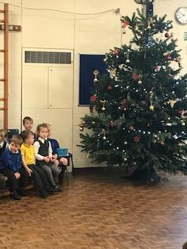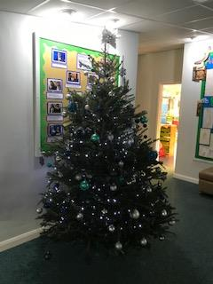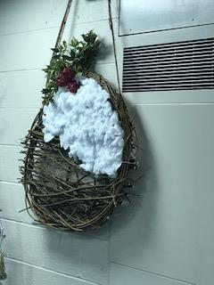
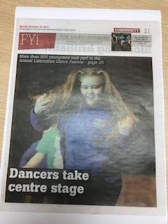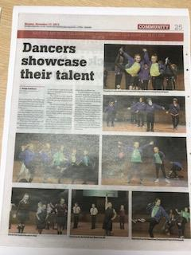
Our dancers got front page coverage in the Blackpool Gazette! They have worked so hard to put together their showpiece and their effort was clearly noticed. I am very proud of the children and the dedication Miss Howarth and Miss Watmough have shown towards this extra- curricular activity.
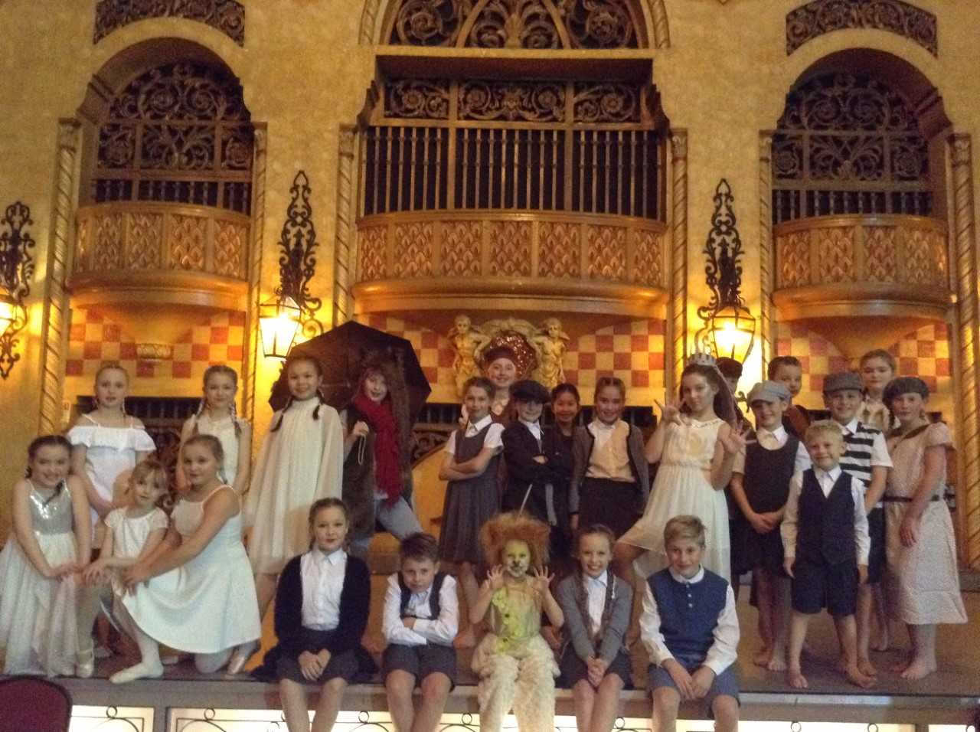
Children who attend dance club represented school this week at The Wyre and Fylde Dance Festival which was held at The Winter Gardens. This year the theme was 'Fantasia' and the children danced a dramatic performance to The Lion, The Witch and The Wardrobe. The children’s' performance was outstanding. You can watch the video on the blog and write a comment about the performance.
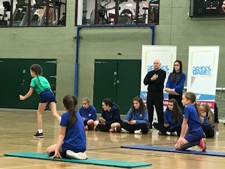
This year we successfully managed to create a team to take to the Indoor Athletics competition held at Blackpool Sports Centre. Children from our Year 5 and 6 classes that attended the weekly morning athletics club, took their starting places with such confidence and although we might not have had every child being the fastest and sportiest, they represented our school well. Thank you to those that assisted with transportation and to those that stayed to support as well.

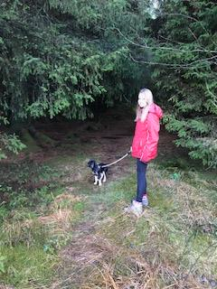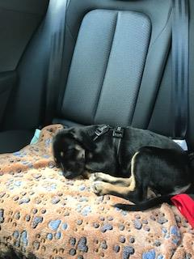
Romeo Update
Romeo is now enjoying his walks. I am thrilled to announce that he is fully toilet trained where he jingles the keys in the door to let us know he wants to be let out and is able to sit, shake a paw, wave, lie down and stay. As you can see above he is quite settled travelling in the back seat of the car with his seat belt and harness and loves being on his lead. This Sunday he went on a walk at Beacon Fell. He has made his first visit to our school this week where he has been led around all the corridors to become accustomed to the sounds and smells of school life. No children yet have come into contact with him as we will be seeking your permission for this beforehand. Thank you for the wonderful emails I have received welcoming him to our family. I loved seeing the video of James Shaw reading to his dog.
The Parent Forum this half term is scheduled to take place on the 4th December from 18:00-19:00. We are to discuss the way we organise our classes across school, our music provision and after school activities. The aim of this evening is for us to actively work together to share ideas to improve further what is currently taking place. I really hope that you will feel this to be a beneficial use of your time and join us. I will write up the findings from the session to share with you all. At our last meeting we discussed at length how to prevent trips being cancelled in the future due to lack of funding. Our forward planning and providing enough notice for the amounts asked to support our plans was considered to be a positive move and it was suggested that updates of payments to be reported weekly on our newsletters. We still however, have significant amounts outstanding. With this being the last payday before the end of term I thought I should share the current picture and figures with you:
EYFS
45 children @ £20 900.00
Payment received from 31 families 620.00
BALANCE OUTSTANDING £ 280.00
KS1
91 children @ £22.00 2002.00
Payment received from 65 families 1418.00
BALANCE OUTSTANDING £ 584.00
LOWER KS2
88 children @ £24.00 2112.00
Payment received from 59 families 1388.00
BALANCE OUTSTANDING £ 724.00
UPPER KS2*
90 children @ £30.00 2700.00
Payment received from 67 families 1990.00
BALANCE OUTSTANDING £ 710.00
£2,298.00
*Year 5/6 have already had their first trip and we were £182.16 short. Some families are entitled to a subsidy through the Pupil Premium grant. This is not an automatic entitlement so please make contact regarding this. If there are families that need assistance and who may not be eligible for Pupil Premium please contact us as we may be able to assist with a subsidy or set up a payment plan.
https://www.parentpay.com/public/client/security/#/login or pay via a cheque.

Singing sessions for our Christmas Candlelit Carol Service at Rossall Chapel are underway. We hope that this will be as well supported as it has been over the past few years. Please remember that the chapel is a chilly venue and so come wrapped up for a festive evening. Some of our children have started learning the ukulele with Mr Jones. We are looking forward to a presentation soon. We enjoyed listening to Lucy Redman playing the piano as the entrance music for Owls’ Class assembly this Tuesday. It takes a huge amount of confidence to perform in front of an audience and we would like to encourage this from other talented musicians.
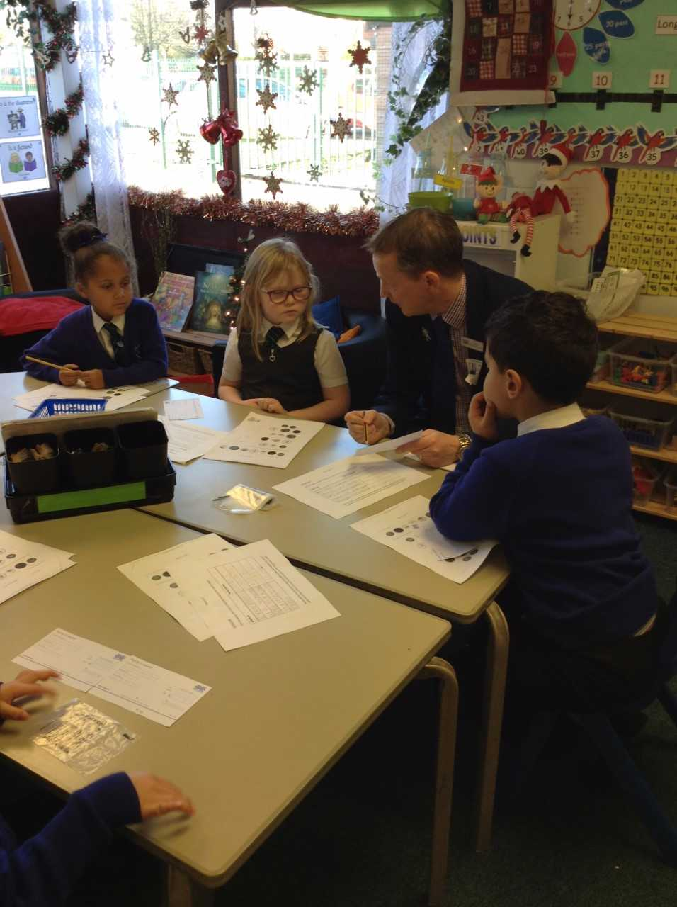
Today in KS1, the children have a had a fantastic workshop from Halifax bank. The children have had the opportunity to be bankers and now understand the importance of saving and managing money. They have also been fortunate to take home some goodies with them, including a new money box! A huge thank you to Mrs Hardwick for organising this opportunity.
We have some changes being made to our teaching team over the coming months and felt that is was important I share this information with you. Mrs Chippendale has been absent from school since the Half Term holidays. I am not foreseeing that she will return in the near future and, so I have temporarily taken on the role of the SENCo as well. I will endeavour to meet all your needs to best support your children’s learning but please bear with me. If there are any outstanding SEN matters for your child please let the school office know so that we may look into it and we will get back to you as soon as possible.
Mr Dann has spent his last week in our school. He stepped in to support our cover to release teachers for their Planning, Preparation and Assessment time. He has done a fabulous job covering the range of classes and has really impacted on the learning of the children. His cheery whistle will be missed around our corridors. This role is temporarily to be taken over by Mr Boyle who will ultimately provide the maternity cover for Miss Deane. We thought it prudent that he gains some experience prior to starting his teaching with us in January. At that point we will welcome Mrs Billington to our team. She is to start with us on the 15th January for the spring term.
I arrived at school yesterday morning at about 07:50 to see two different families leave school after dropping their child off at Breakfast Club. Despite requesting that parents do not use the School staff carpark for dropping off and collection purposes; both cars were in our carpark. What I found more alarming was that one car set off at huge speed to vacate the carpark and then proceed to honk their horn at the other car that was also in the process of leaving. Not only is this an unacceptable driving behaviour it took place on our school grounds where children could be walking. Should an accident have taken place we would have been liable.
Many of our neighbours comment repeatedly about the inconsiderate parking habits of our school families. Many have their grass driven over or their driveways/turning circles blocked. I hope that we all may be able to show a greater awareness of others and park with consideration to their property and access needs.
Please do not use our carpark for dropping off or collection purposes.

Lola-Rose Bailey, Annabel David, Harrison Paul, Max Holt, Wiktoria Ziomek, Oliver Russell, George Sorsky, Olivia Frith, Ben Middleton, Joshua Oxley and Harrison Swindells.

Yellow Ducklings  94% with 1 late | Brown Ducklings  98% with 1 late
Parrots  94% with 1 late | Herons  95% with 3 lates
Robins  95% with 4 lates | Owls  98% with 1 late
Doves  94% with 4 lates | Kestrels  95% with 1 late
Falcons  95% with 0 lates | Hawks  92% with 1 late
Eagles  96% with 1 late | Well done to those for making it to school every day on time!

The children have organised the recent charity events this term and we have raised £284.59 for Wear it Pink and £352.59 for Children in Need. Thank you very much for your support. The children on the Charity Committee meet every half term to discuss fund raising events. Please look on the dates section for updates.

Thank you for all your continued support for all that takes place inside and beyond school.
Susan McGrath Headteacher.

Community News ~ Tomorrow there is a Christmas Fair at Thornton Methodist Church. It is to be open from 10:00-14:00 with a variety of stalls. Father Christmas will also be making an appearance.

