We have held some lovely events recently with a fabulous interhouse Rounders tournament organised by Miss Howarth for our juniors. The children loved competing against one another. Poseiden won in lower Key Stage 2 and Athena were the winning team for upper Key Stage Two.
Our second day saw the children exercising to help those in Nepal. The idea to raise money to help those in Nepal came from in Thomas McLaughlin Year Two. Our School Council had organised all the events under the close supervision of Mrs Crooks. This event raised a fabulous £1469.00!!! Thank you for all your support.

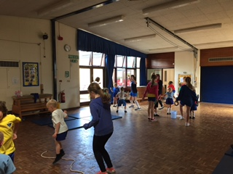
Our Sports’ Day was also an amazing occasion where the school could come altogether. Our school looked stunning with our team 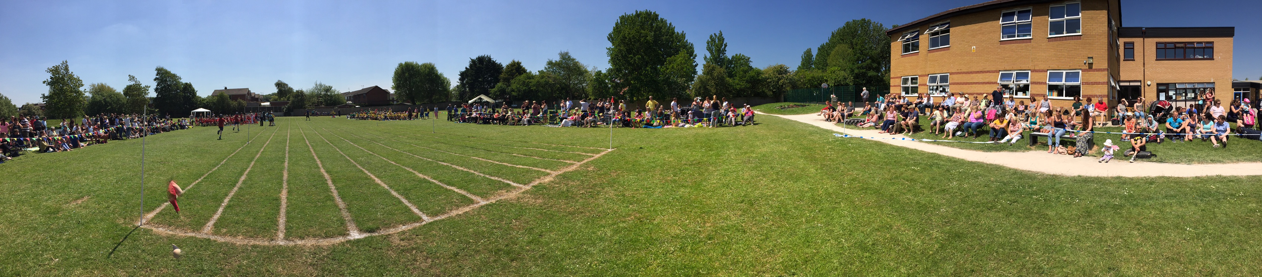
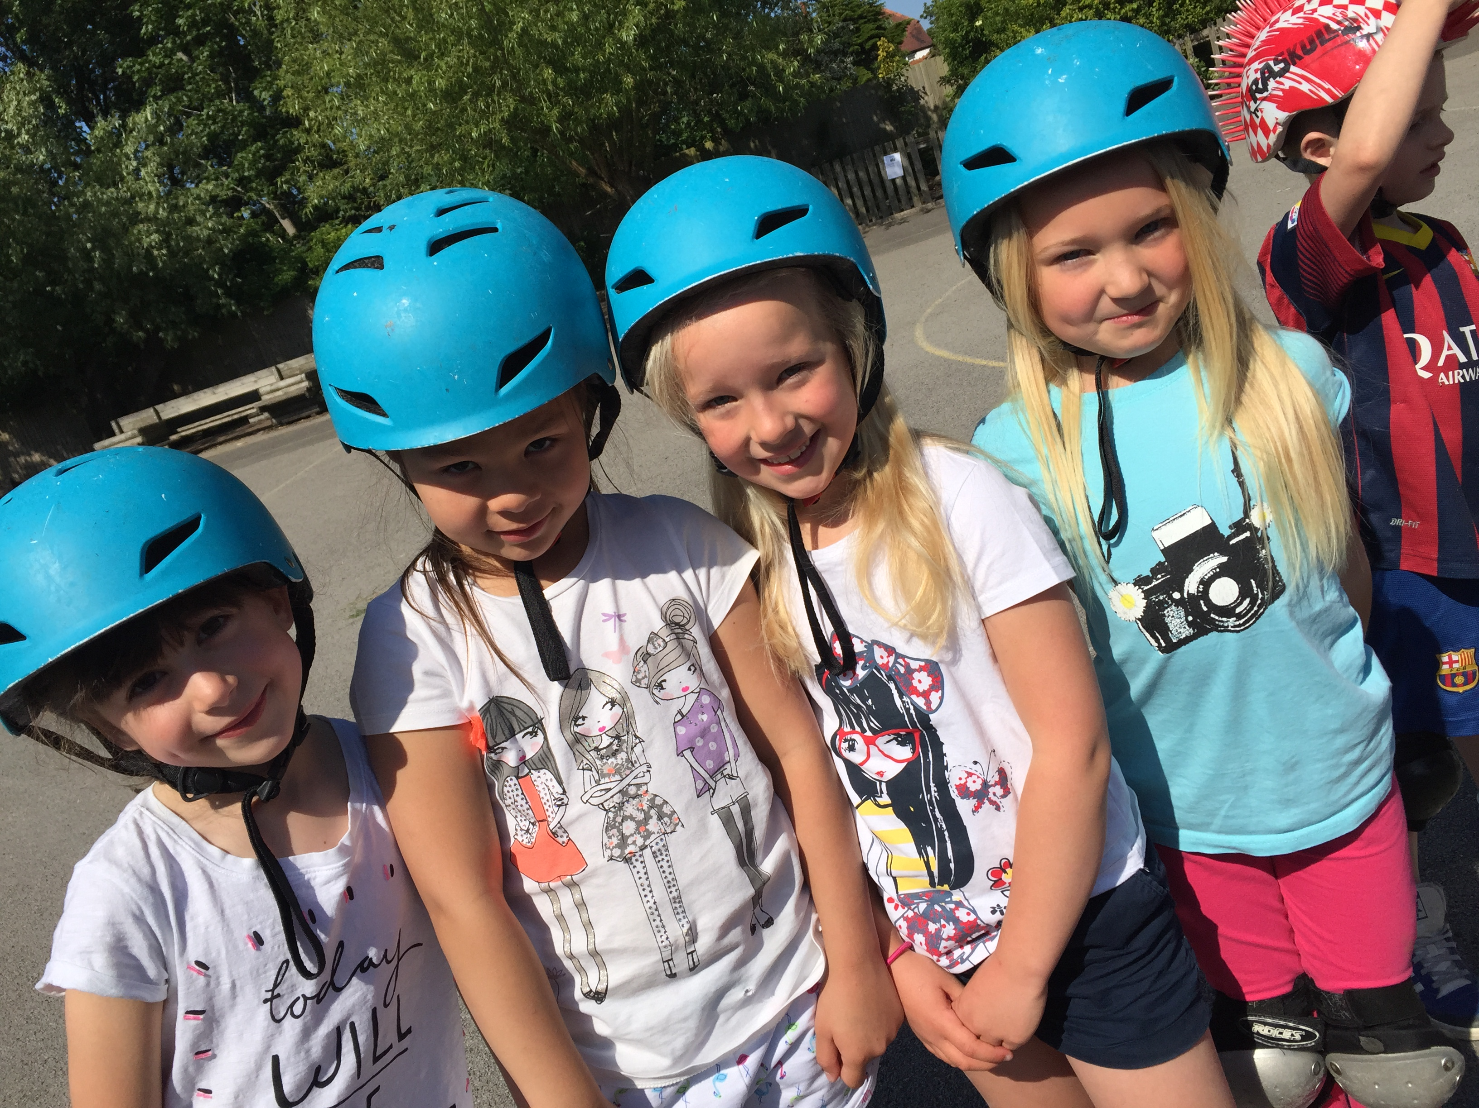
coloured t-shirts. Once again, it is wonderful having the support from our families and we are very grateful for so many spectators. I am very glad that the sun was shining. Although it feels more autumnal now than summer time, please ensure that your child has got suncream in school as well as a drink to help keep them hydrated through the day should the sunshine hopefully make a return.
Scooter Day was a great success too and the children had fun developing their skills.
This week we have been able to award Carleton Codes to:
Daniel Workman, Amy Atherton, Lexi Nelson, Ella Reader and
Nathaniel Merricks.
This is a huge achievement!
I would like to ask that parents continue to be vigilent regarding the use of social media It has once again come to our attention that some of our pupils are using sites to communicate to their peers and that this communication is not always of a positive nature. This type of activity places your child in a vulnerable position.
We have now been informed that the funeral for Little Thomas Dean is to be held on the 23rd June in St Chad’s Church, Poulton-Le-Fylde at 12:30. As a school we want to hold a rememberace day for him on Monday 29th as our way of saying our goodbyes. We have planned lots of fun maths activities to carry out over the day with snacks and a lunchtime picnic with the foods that he loved.
Star of the Week certificates have been awarded to:
Ruben Lear from Yellow Ducklings. | Isabella Ibbison from Green Ducklings.
Oliver Brady from Parrots | Kaysha Ryan from Herons
Layla Rose Ronson from Robins | Daniel Pilling from Owls
William McVicar from Doves | Nathan Osborne from Kestrels
Hannah McNaughton from Hawks | Adam Bagshaw from Falcons
Robin Turner from Eagles | Well done everyone!

Up and coming events:
Fathers’ Day Film Night 18th June – 18:00-19:30 -sadly this was cancelled due to the lack of interest.
22nd June ~ Our duck eggs arrive for incubation.
Boys’ Swimming Gala – Tues. 23rd June 2015
Girls’ Swimming Gala – Thurs. 25th June 2015

26th June ~ Summer Fair 15:30-19:00  Non-Uniform Day
If you are able to help at all in any way please get in touch with school. Thank you to those that already have done so.
Monday 29th June ~ Thomas Dean Maths Day.
1st July ~ Got to Dance competition.
2nd July ~ Voice and Musician of the Year competition.
Week beginning 6th July ~ Year Six Camp 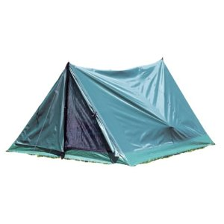with Mrs McGrath, Mrs Harding, Mrs Crooks, Mr Boyd, Miss Howarth & Mr Jones
Tuesday 14th July – End of Year Reports to go home with an annual parent and pupil questionnaire.
Wednesday 15th July – Meet the Teacher Evening and drop in for End of Year Reports.
Week beginning 20th July ~ Leavers Events – Awards Evening/Leavers Disco and BBQ for Year 6 pupils and parents, End of year production with year 5 & 6 pupils, End of term Assembly.
22nd July ~ School closes at 14:30 for the summer holidays.
Friends of the Jean Stansfield Memorial Park in Poulton are holding a music festival called 'The Big Gig' in the park on Sunday 12th July. There will be live music throughout the day, including performances from The Deadbeats, Poulton People's Choir, The Keytars, Ark, Ian Hooper, Solid States and many more, as well as The Young New Talent Award showcase for under 16's sponsored by Lloyds BMW. There will also be a mini fair, refreshments and fundraising for new play equipment on the day.
It is advertised to be a fantastic family day where the whole community can come together through music, at the same time as supporting the local park.

SUMMER FAIR 2015
Friday 26th June from 3pm

As you are aware the Summer Fair is approaching fast. To enable us to have as many stalls/events as possible running we require the help of parents. Why not share a stall with a friend

Please will you kindly complete the reverse of this letter and return to the school office as soon as possible. Your name will be added to the schedule and we will reconfirm all requests shortly, then you just need to turn up on the day!

Once again we will be doing year group contributions to be brought in on the non-uniform day (19th June) as follows:

Ducklings sweets
Year 1&2 bottles
Year 3&4 chocolates / cakes / biscuits
Year 5&6 new prizes for children’s tombola

DETAILS OF PLANNED STALLS ARE ON THE REVERSE OF THIS LETTER – PLEASE INDICATE BY TICKING ON THE GRID WHERE YOU ARE ABLE TO HELP AND PROVIDE YOUR DETAILS BELOW SO WE CAN CONTACT YOU.

Name(s): .........................................................................................

Tel No(s) .........................................................................................
Help set up fair |  | From 1pm
Help take fair down
Refreshments
BBQ
Bouncy Castles
Coconut Shy
Panning for Gold
Face Painting
Nail Art
Tattoos
Play Your Cards Right
Splat the Rat
Children’s Tombola
Adult Tombola
Apple Bobbing
Hook a Duck
Grab a Frog
Basketball
Welly Throw

